- …
  - The user is asked to enter a pupil’s name. Their input, ‘Keon,’ is stored in the variable name.
The user is asked to enter the score achieved by the pupil, out of a maximum of 80. Their input, ‘70’, is stored in the variable count_result.
The variable count_result is multiplied by 1.25, and its product is rounded to the nearest whole number, which is then stored in the variable count_percentage. Thus, 70 × 1.25 = 87.5, rounded up to 88. The value 88 is stored in count_percentage.
The ‘%’ string is appended to the value count_percentage, and this string is then output for 2 seconds. Thus, the string ‘88%’ is output for 2 seconds.
If the variable count_percentage is greater than 85, then the name variable is added to the variable list wren_list. 88 > 85. Thus, wren_list now has the value ‘Keon’ appended to it.
Excellent!
  - …
    - The value ‘85’ may be stored as a constant because it is used as a fixed value for the final comparison that decides whether the name variable should be appended to the wren_list.
    - min_percentage
Yes, good!
  - 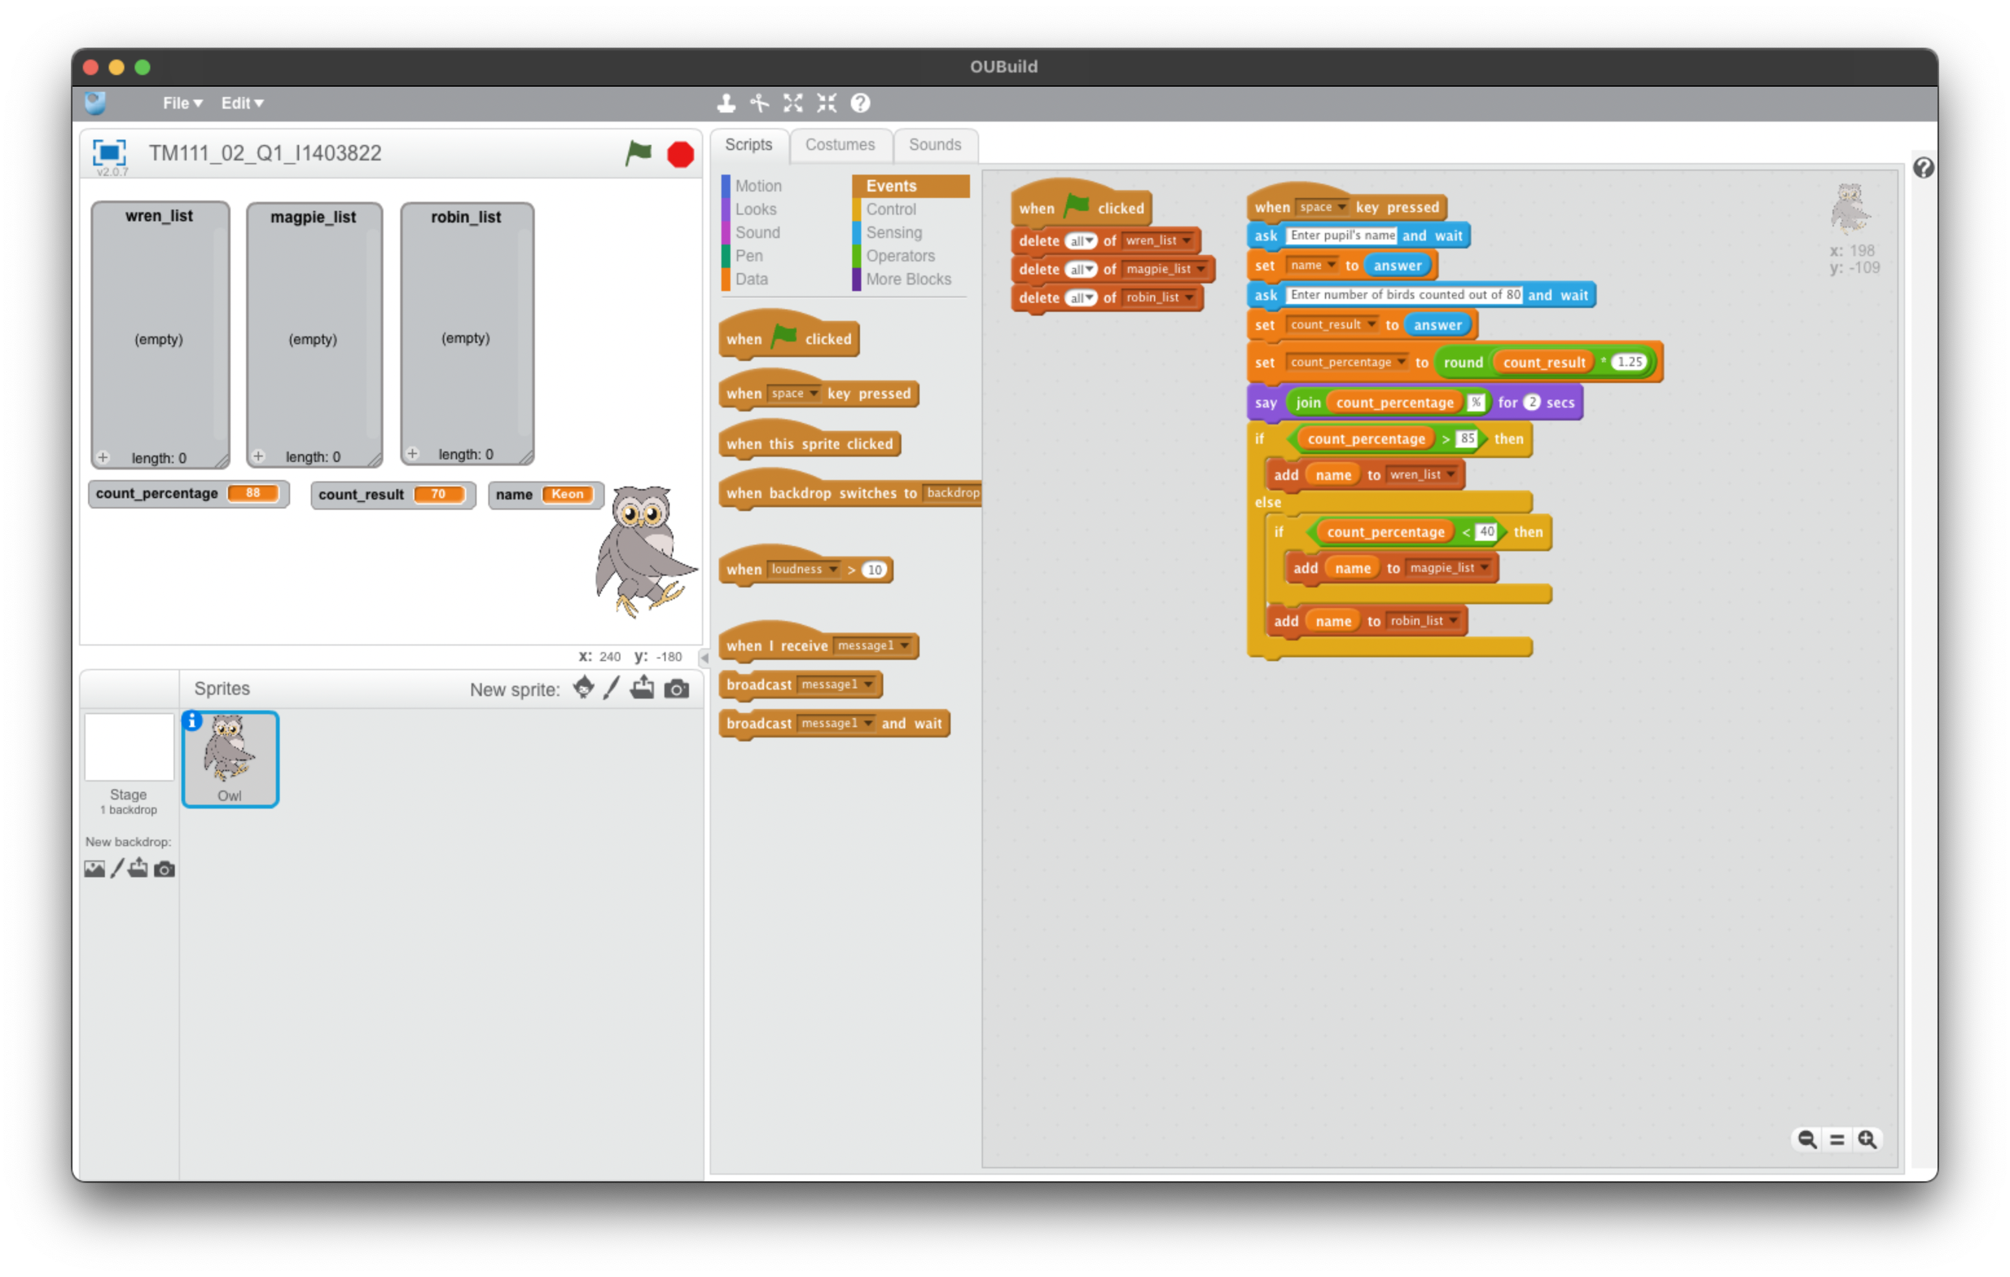
This is not quite correct. For part c you were only required to use wren_list and magpie_list. A possible solution is as follows:
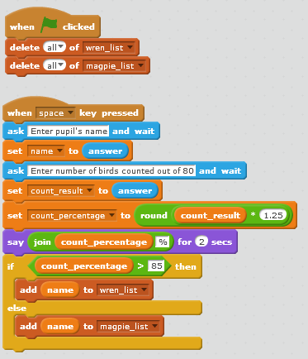
  - …
    - 
This is almost correct. However, numbers which are both less than 85 and less than 40 are added to both magpie and robin lists. A possible solution is as follows:
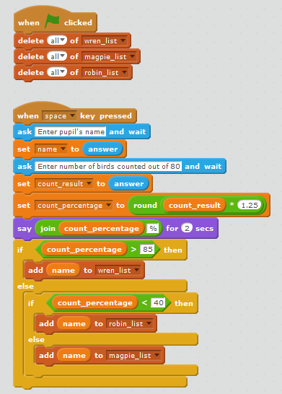
    - In my case, I have used a pair of nested if/else statements since there were only two conditions to be met for this case scenario. In any case, another method would be to make a single loop statement, wherein the loop is run once, and inside this loop, if statements are used to check for all conditions.
I am not quite sure what you are intending here. The two possible forms involve nested if<>then{}else{} blocks (see example solution for part i) or a sequence of if<>then{} blocks.
See sequential versus nested selection, numerical comparisons – Part 3 Section 3.2.1, 3.2.3

- 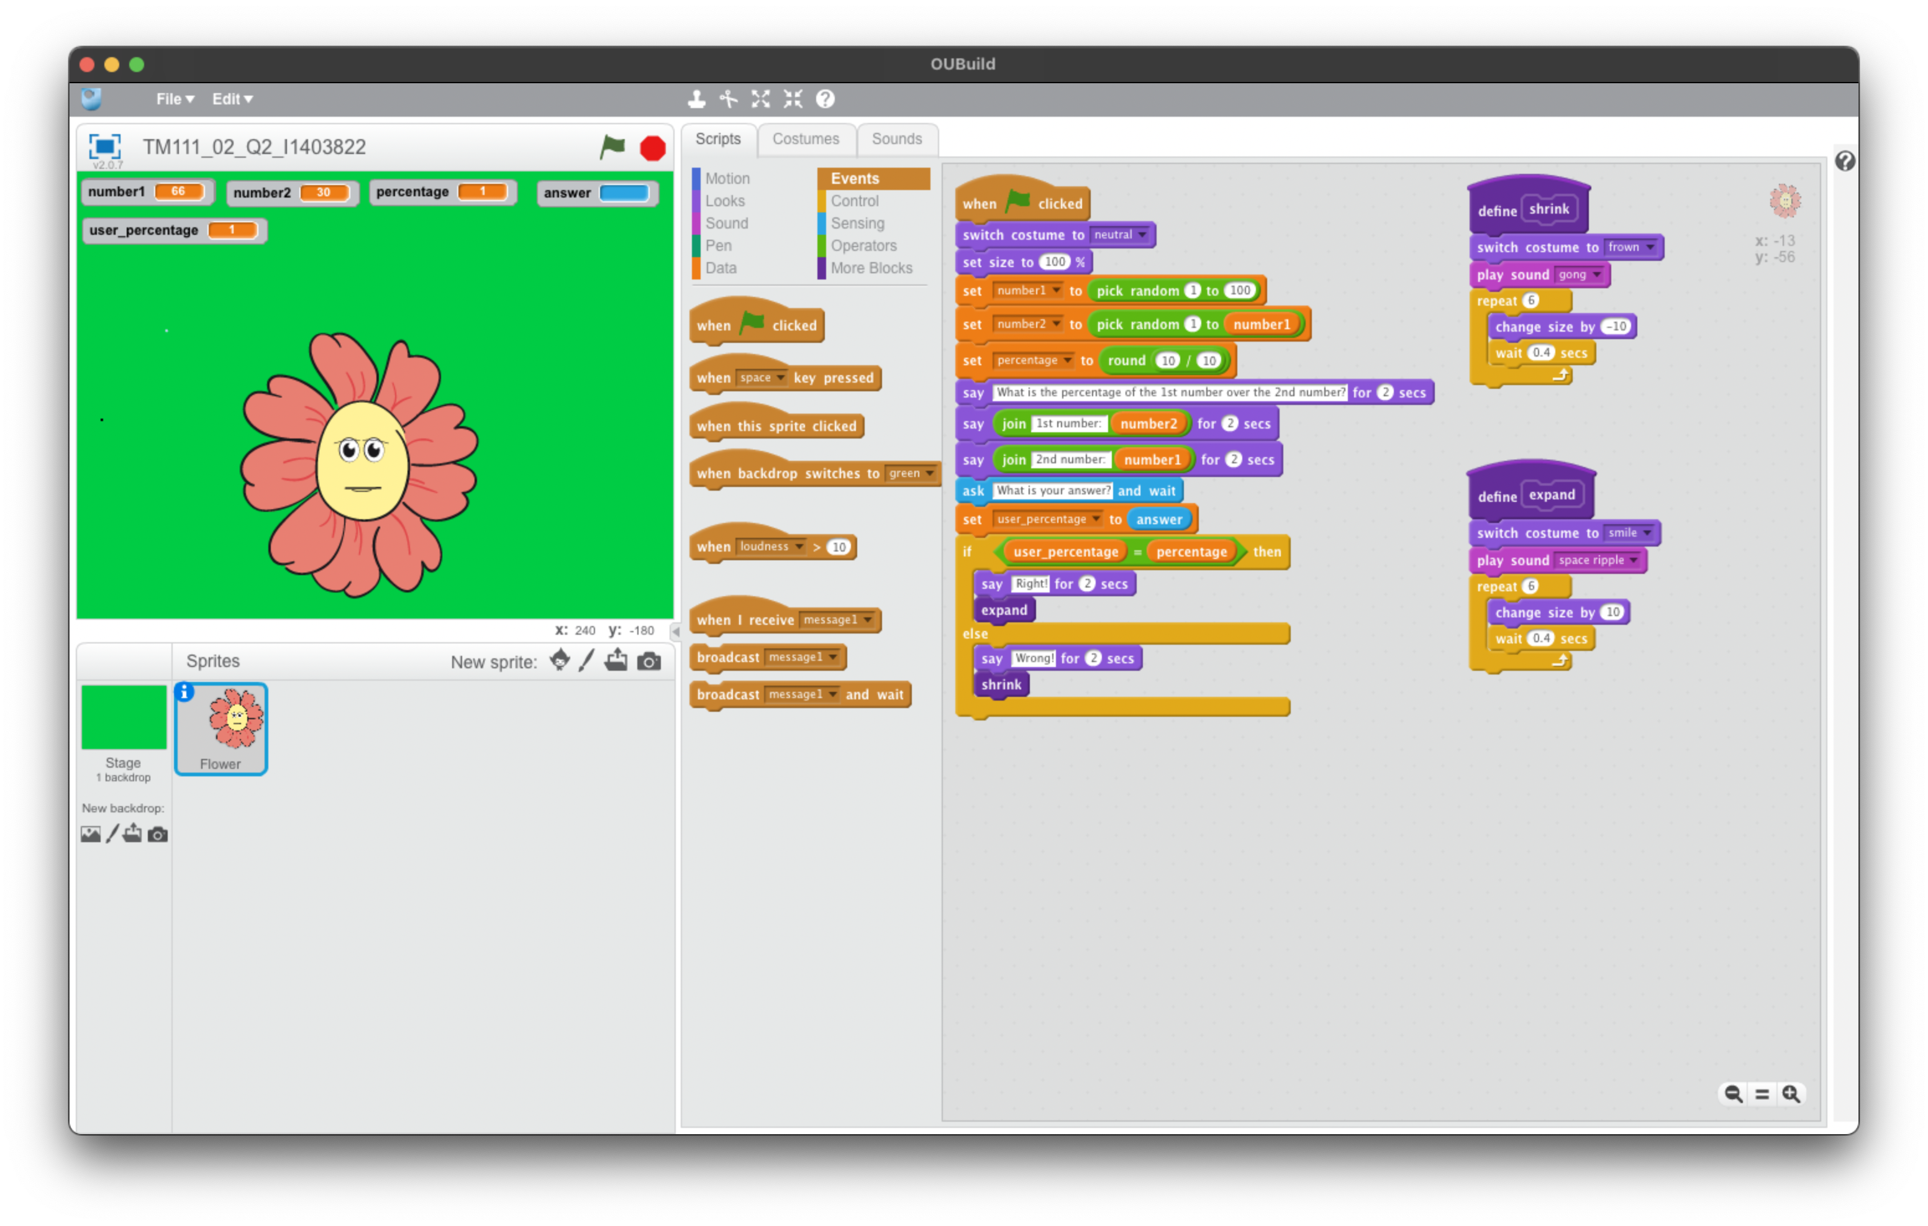
A lot of this works. However, there are a few errors.
You have initialized the flower, wearing costume ‘neutral’ and generated the numbers correctly. However, you have not correctly calculated the right percentage answer (See Arithmetic – Part 2 Section 2.1.1). This can be calculated using the following blocks:
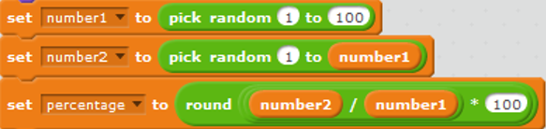
You have formed the question in a slightly different way from that expected by the question, but it does meet the criteria.
You have correctly obtained user input and compared with your answer (which is incorrectly always ‘1’ in this case). However, you do not tell the user the ‘correct’ answer if they have made a mistake.
You have created an acceptable ‘expand’ definition script.
- …
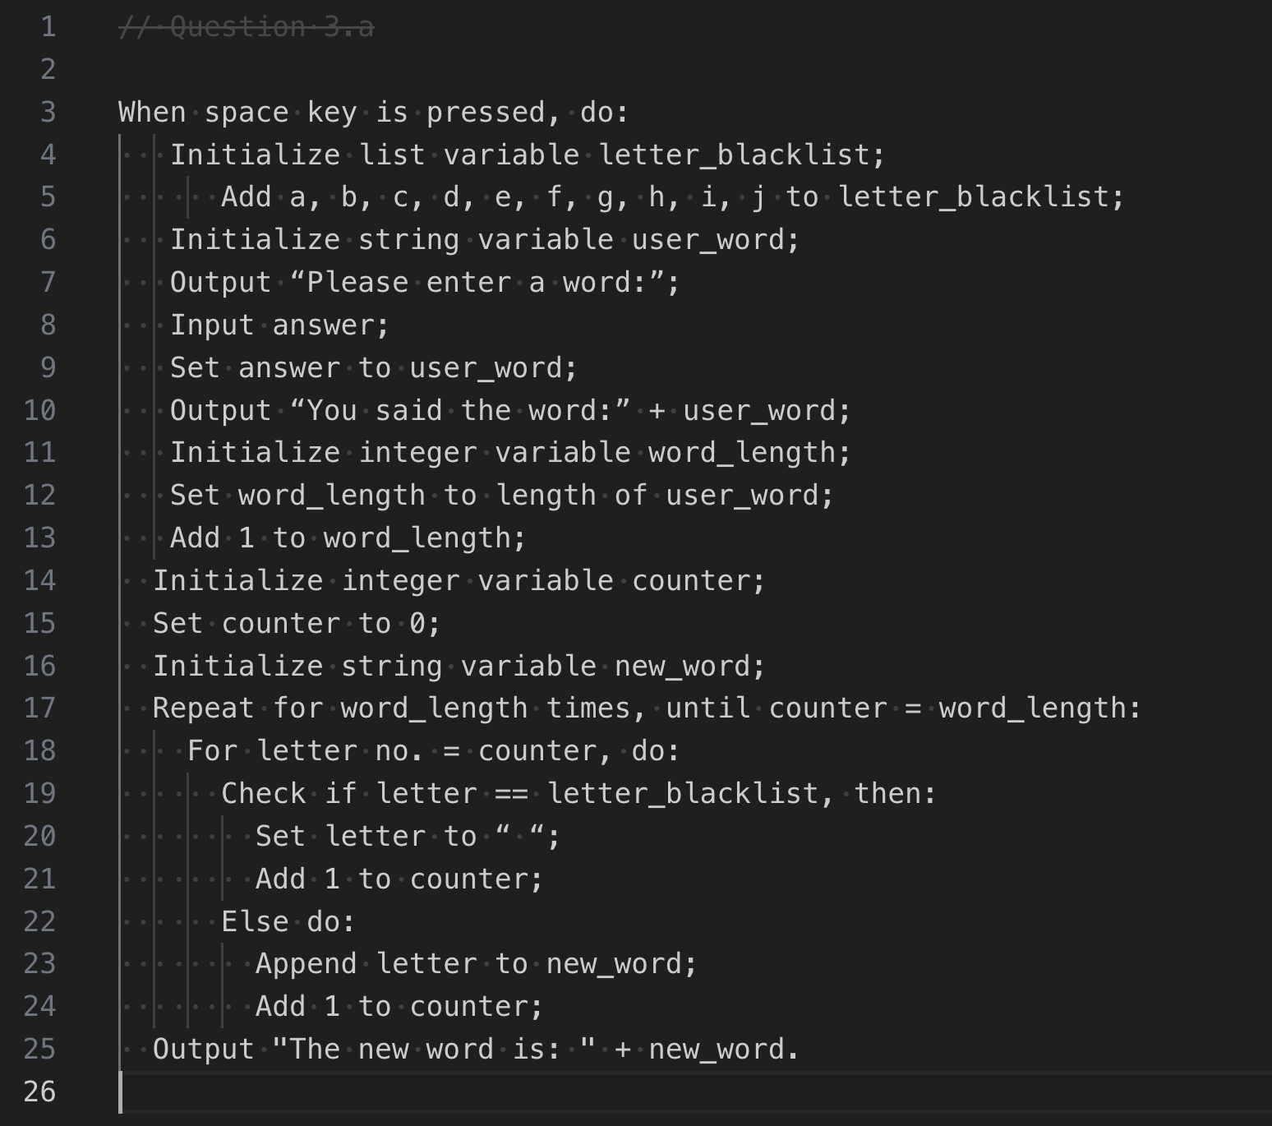
Yes, this is good!
  - 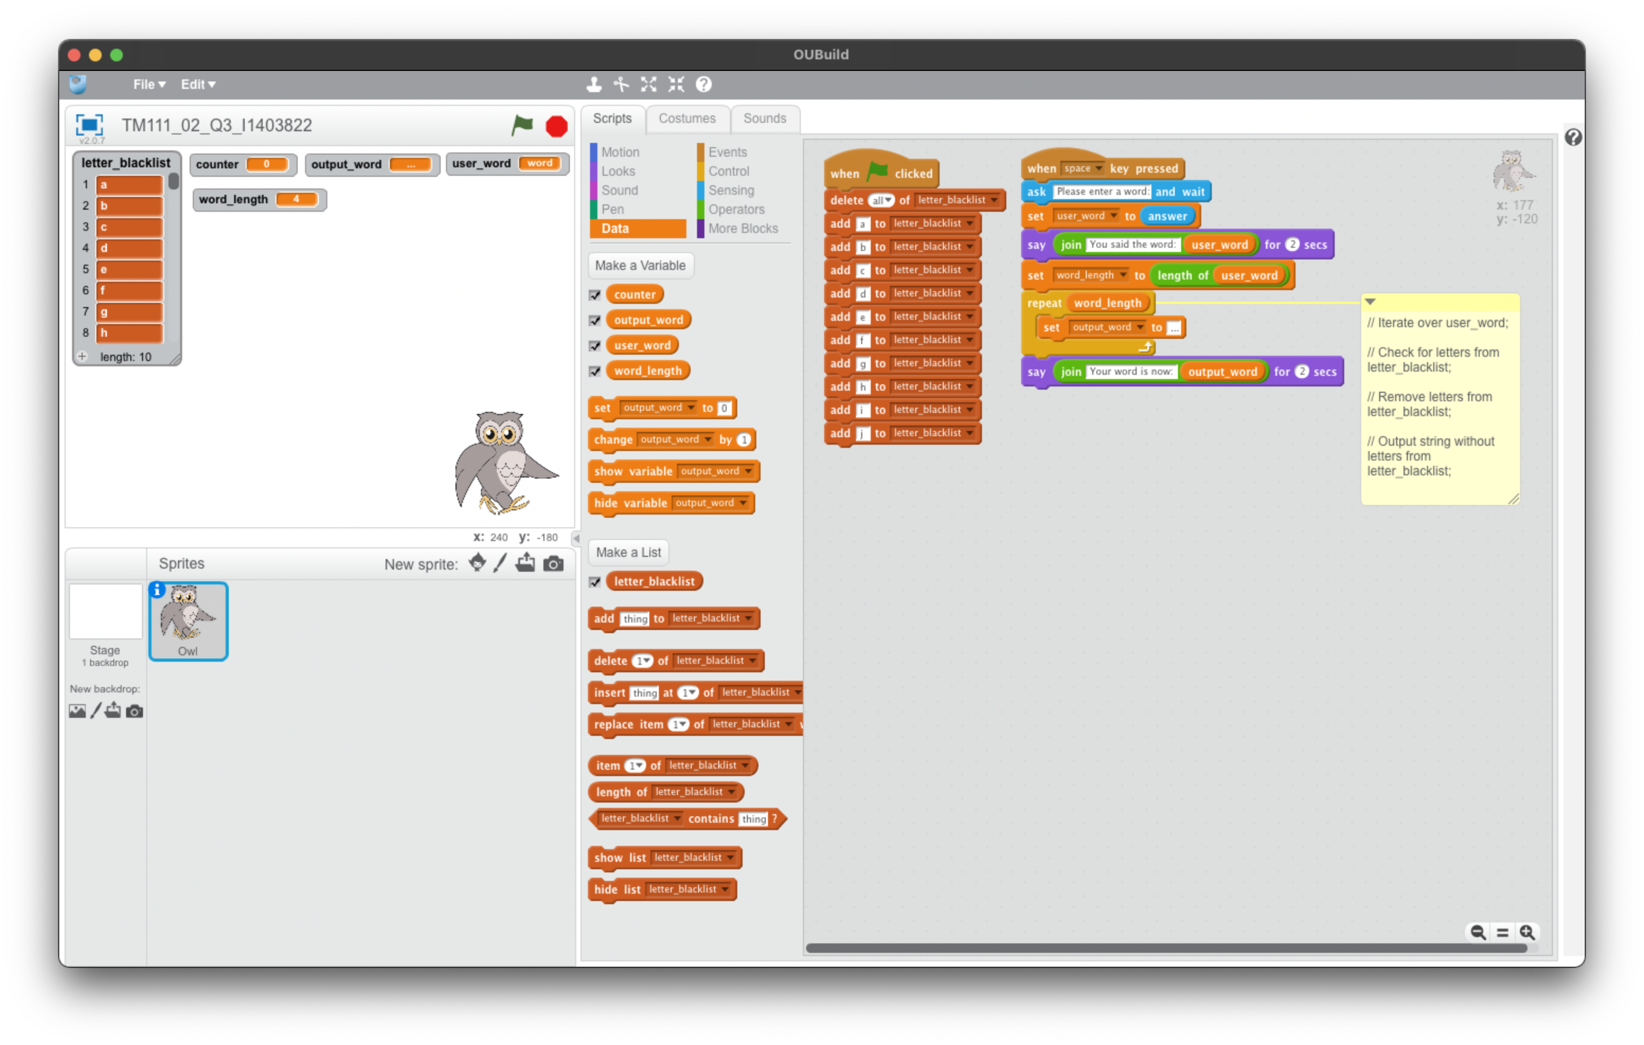
This is not quite correct.
You have not full setup and initialized all variables or successfully repeated the process over the letters of the word.
A possible solution might be:
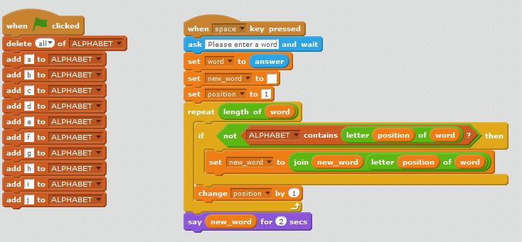
See Repetition– Part 4 especially Section 4.4 (Problem-solving with repetition) and in particular Activity 4.8 which uses a list of specific characters.

Test number | Test purpose | Inputs, Word | Expected results, new word displayed
1 | The first and last letters are in the first 10 letters of the alphabet | apple | ppl
2 | Word does not have the first 10 letters of the alphabet | xyz | xyz
3 | Word has only the first 10 letters of the alphabet | abcdefghij | (intentionally blank)
  - …
These are appropriate tests, well done!
- …
  - …
Test number | Test purpose | names | least | greatest
1 | Least name at position 1, greatest at position 3. | B, I, X, E, R, Q, W, V, D, S | 1 | 3
2 | Number of comparisons is equal to 35 when size of list is 10. | B, I, X, E, R, Q, W, V, D, S | 35... | ...comparisons
3 | Sort is made correctly. | B, I, X, E, R, Q, W, V, D, S | B, D, E, I, Q... | ...R, S, W. V, X

I can see what you have done here, although this question was looking for testing results in terms of ‘least’ and ‘greatest’; for example:

Test  no. | Test purpose | Existing  data | Expected results
 |  | names | least | greatest
1 | Least name at position 1, greatest at position 3. | B  I  X  E  R  Q  W  V  D  S | 1 | 3
2 | Least name at position 10, greatest at position 3. | S  I  X  E  R  Q  W  V  D  B | 10 | 3
3 | Least name at position 3, greatest at position 10. | S  I  B  E  R  Q  W  V  D  X | 3 | 10

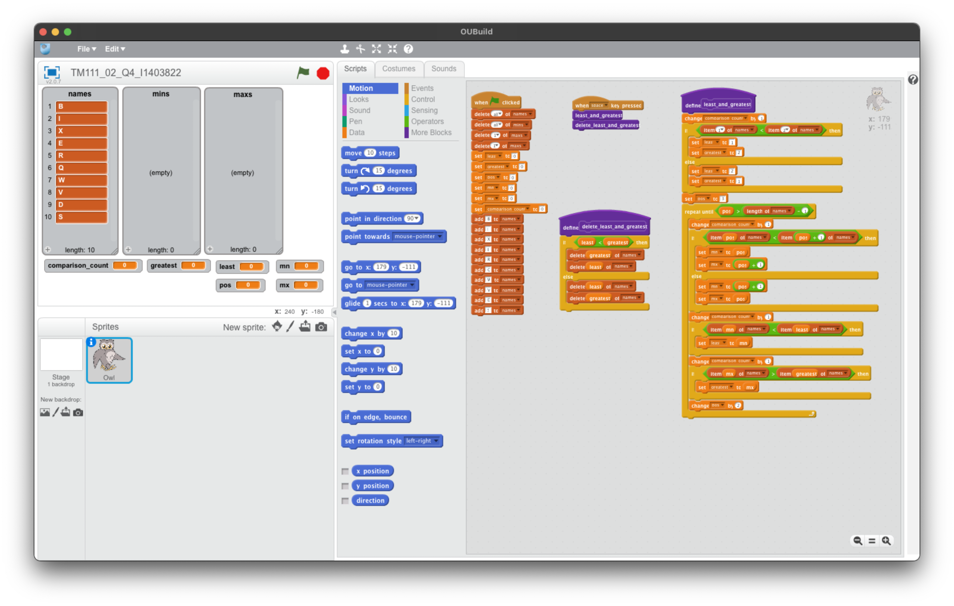
I can see what you have done here. This is a very different approach than might normally be expected by the question but does seem to work in terms of meeting the criteria.
This is another possible approach (keeping all other parts of the program as given):
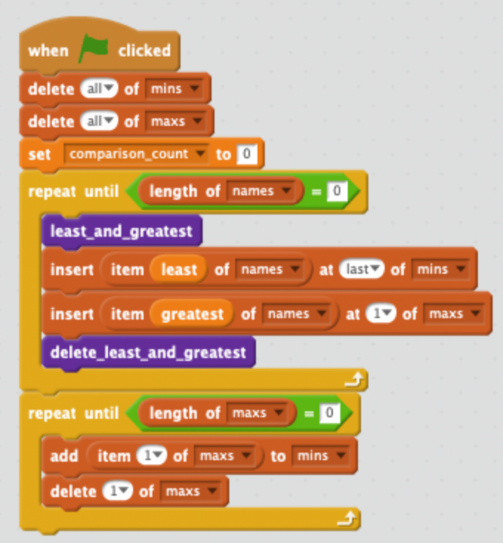
    - 
    - ...
Size of list | 10 | 20 | 30
Number of comparisons | 35 | 145 | 329

Almost:
Size of list | 10 | 20 | 30
Number of comparisons | 35 | 145 | 330

    - No, it does not, because [n × (n – 1) / 2] × 0.75 follows a quadratic pattern.
You are correct that it is not linear
    - 0.75 × n × (n – 1) / 2
Size of list (n) | 10 | 20 | 30
n × (n – 1) / 2 | 45 | 190 | 435
0.75 × n × (n – 1) / 2, rounded up to the next whole number | 34 | 143 | 327

Yes, and the numbers in the last row are all close to the measured values from part (ii) but slightly less.
If we work out 0.75 × n × (n – 1) / 2 with n = 1,000 we get 374,625, and we expect this is a bit below the actual value, so 375,000 to the nearest 1,000 would be a reasonable estimate.
I cannot see a response to part d

